**Assignment 7 (20 points), SE 421, 10/20/2021, due: Wednesday, 10/27/2021**

**Name (Last, First):**

**Submission Requirement**: Submit a PDF named HW7-lastname-firstname. Include the top two lines with your last and the first name. Include the problem statement followed by your answer.

**Problem 1 (5 points):** Answer the following questions for the given code, without using Atlas.

**1. int main(bool c1, bool c2, bool c3) {**

**2. int a1, a2, x, d;**

**3. int *p1,*p2,**q1,**q2;**

**4. a1 = 3;**

**5. a2 = 5;**

**6. p1 = &a2;**

**7. p2 = &a1;**

**8. q2 = &p1;**

**9. if(c1){**

**10. *p1 = 5;**

**11. } else{**

**12. *p2 = 7;**

**13. }**

**14.q1 = &p2;**

**15. if(c2){**

**16. x = *p1;**

**17. if(c3){**

**18. a2 = **q1;**

**19. } else {**

**20. d = x - **q2;**

**21. }**

**22. } else {**

**23. d = d + 1;**

**24. }**

**25. z = x/d;**

**26. print(a1+z)**

**29. }**

1. (2 points) List out the all the live definitions at line 20.
   1. (4, a1) (5, a2) (6, p1) (10, p1) (7, p2) (12, p2) (8, q2) (14, q1) (16, x) (20, d)
2. (1 point) Draw the *backward slice* starting with the use of **d** at line 25.
   1. Diagram

      Description automatically generated
3. (1 point) Is there any DVZ vulnerability in the above program? Explain using backward slice.
   1. Yes, if you follow the backward slice up from 25 d is passed from node 23 and 20 but 23 doesn’t cause an issue since d is not -1 and that is what the value you would need to be to obtain 0. So going from node 20 we can see that d is composed of x and **q through subtraction and so we want to see when **q is equal to -x or x. Following node 20 we see x is assigned the value of p1. Moving up again we see that the value of p1 is set to 5 at node 10 and that at node 8 q2 is set to the address of p1. Moving up again we see that p1 is set to the address of a2 at node 6. Then at node 5 we see that the value of a2 is set to 5. This we can see will lead to d = 5-5 which will give a DVZ at line 25.
4. (1 point) How many *def-use* (DU) chains starting with the definition of **a2** at line 5?
   1. 4

**Problem 2 (4 points):** Let T(p), the target of the pointer p, be the *set of objects* that p points to. If the p does not point to anything, then T(p) = null. Let O1, O2, O3 be the objects allocated by the successive **malloc** calls. Give the values of T(X), T(Y), T(p), T(q) at each of the two program points which are shown below for each of the following two code segments.

*At the Program Point 1***:**

T(X) = {O1} T(Y) = {O2} T(p) = null T(q) = {Y}

*At the Program Point 2***:**

T(X) = {O1} T(Y) = {O2} T(p) = null T(q) = {Z}

*At the Program Point 3***:**

T(X) = {O1} T(Y) = {O2} T(p) ={O1,O2,O3} T(q) = {X,Y,Z}

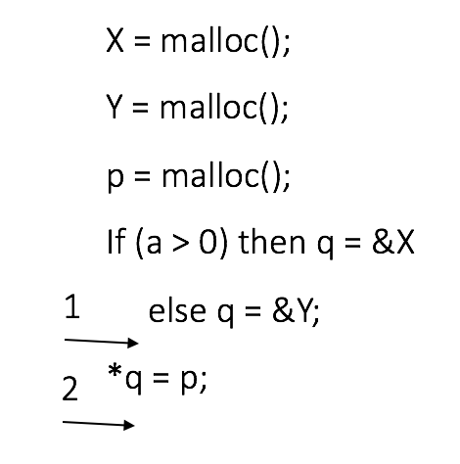

*At the Program Point 1***:**

T(X) = {O1} T(Y) = {O2} T(p) = {O3} T(q) = {X,Y}

*At the Program Point 2***:**

T(X) = {O1} T(Y) = {O2} T(p) = {O3} T(q) = {P}

**Problem 3:(2 points)** Assume that each branch is 2-way.

1. Suppose there are three non-nestedbranch statements such that each branch has one definition **V**. How many *definitions of* **V** reach the *use of* **V** right after the three branch statements?
   1. 3
2. Suppose one definition of V is followed by three non-nested branch statements such that each branch has one use V. Assume there are no other uses of **V**. How many *uses* of V for the definition of V?
   1. 3

**Problem 4 (7 points):** Access to the allocated memory is passed as a parameter drptr (a pointerto the allocated memory) to the function dskenq. Another parameter to dskenq is dsptr, a pointer to a global data structure. Read the code segment carefully to answer the following questions.

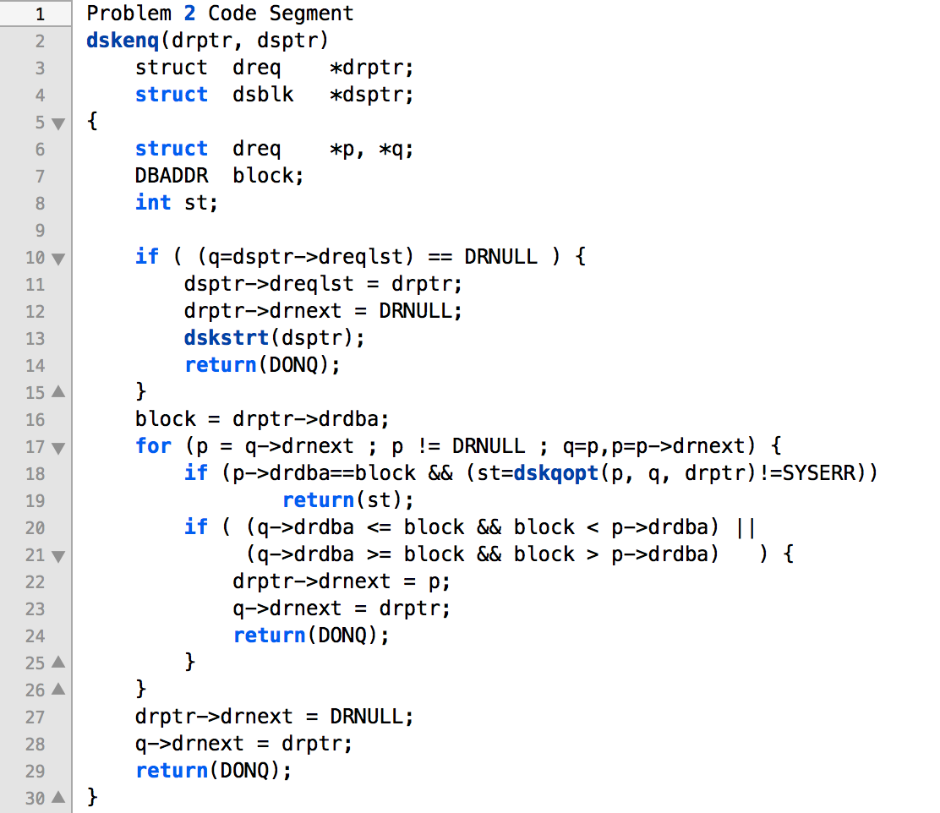

1. **(2 points)** Does dsptr provide access to the allocated memory at line 13? If yes, explain in one sentence how.
   1. **Yes because you set the allocated memory drptr to the ->dreqlst of dsptr and then in dskstrt(dsptr) you move dsptr = dsptr->dreqlst which is where we allocated the memory.**
2. (**1 point**) Does dsptr provide access to the allocated memory at line 16?
   1. No
3. (**2 points**) How many definitions of q are there in the given code? Give the line numbers for those definitions.
   1. 2 line numbers 10 & 17
4. (**2 points**) Let C1 and C2 denote the conditions for the branch statements at lines 18 and 20 respectively. Assume that the loop at line 17 does terminate. Complete the following truth table. The last column of the truth table is either YES or NO depending on whether the definition of q at line 17 reaches the use of q at line 28 along at least one control flow path.

|  |  |  |
| --- | --- | --- |
| C1 | C2 | The definition of q at line 17 reaches the use of q at line 28 – YES or NO |
| TRUE | TRUE | No |
| TRUE | FALSE | No |
| FALSE | TRUE | No |
| FALSE | FALSE | Yes |

**Problem 5 (2 points + 2 bonus points):** *Import and map CrackMe project contained in crackme.zip*. The goal is to get the secret key generated by the given Java code. This problem was posed as a challenge problem at a cybersecurity competition. The problem is a difficult challenge if one tries fuzzing, which is a common practice at the cybersecurity competitions. Try running the code, you will find that it keeps running with periodic timer messages, but it does not produce the secret key.

The problem is not difficult to solve if you apply the program slicing technique we have studied in class. You can use the Program Slice Smart View (Data Dependence Slice as showed in class). Recall that you specified the appropriate program statement and the variable to compute the slice. An appropriate selection would yield the slice of the relevant code.

1. What are the appropriate statement and the variable for getting the program slice of the relevant code?
   1. Line 48 SecrectKey = suffix.substring(0, 15);
2. Include a graph of the program slice.
   1. 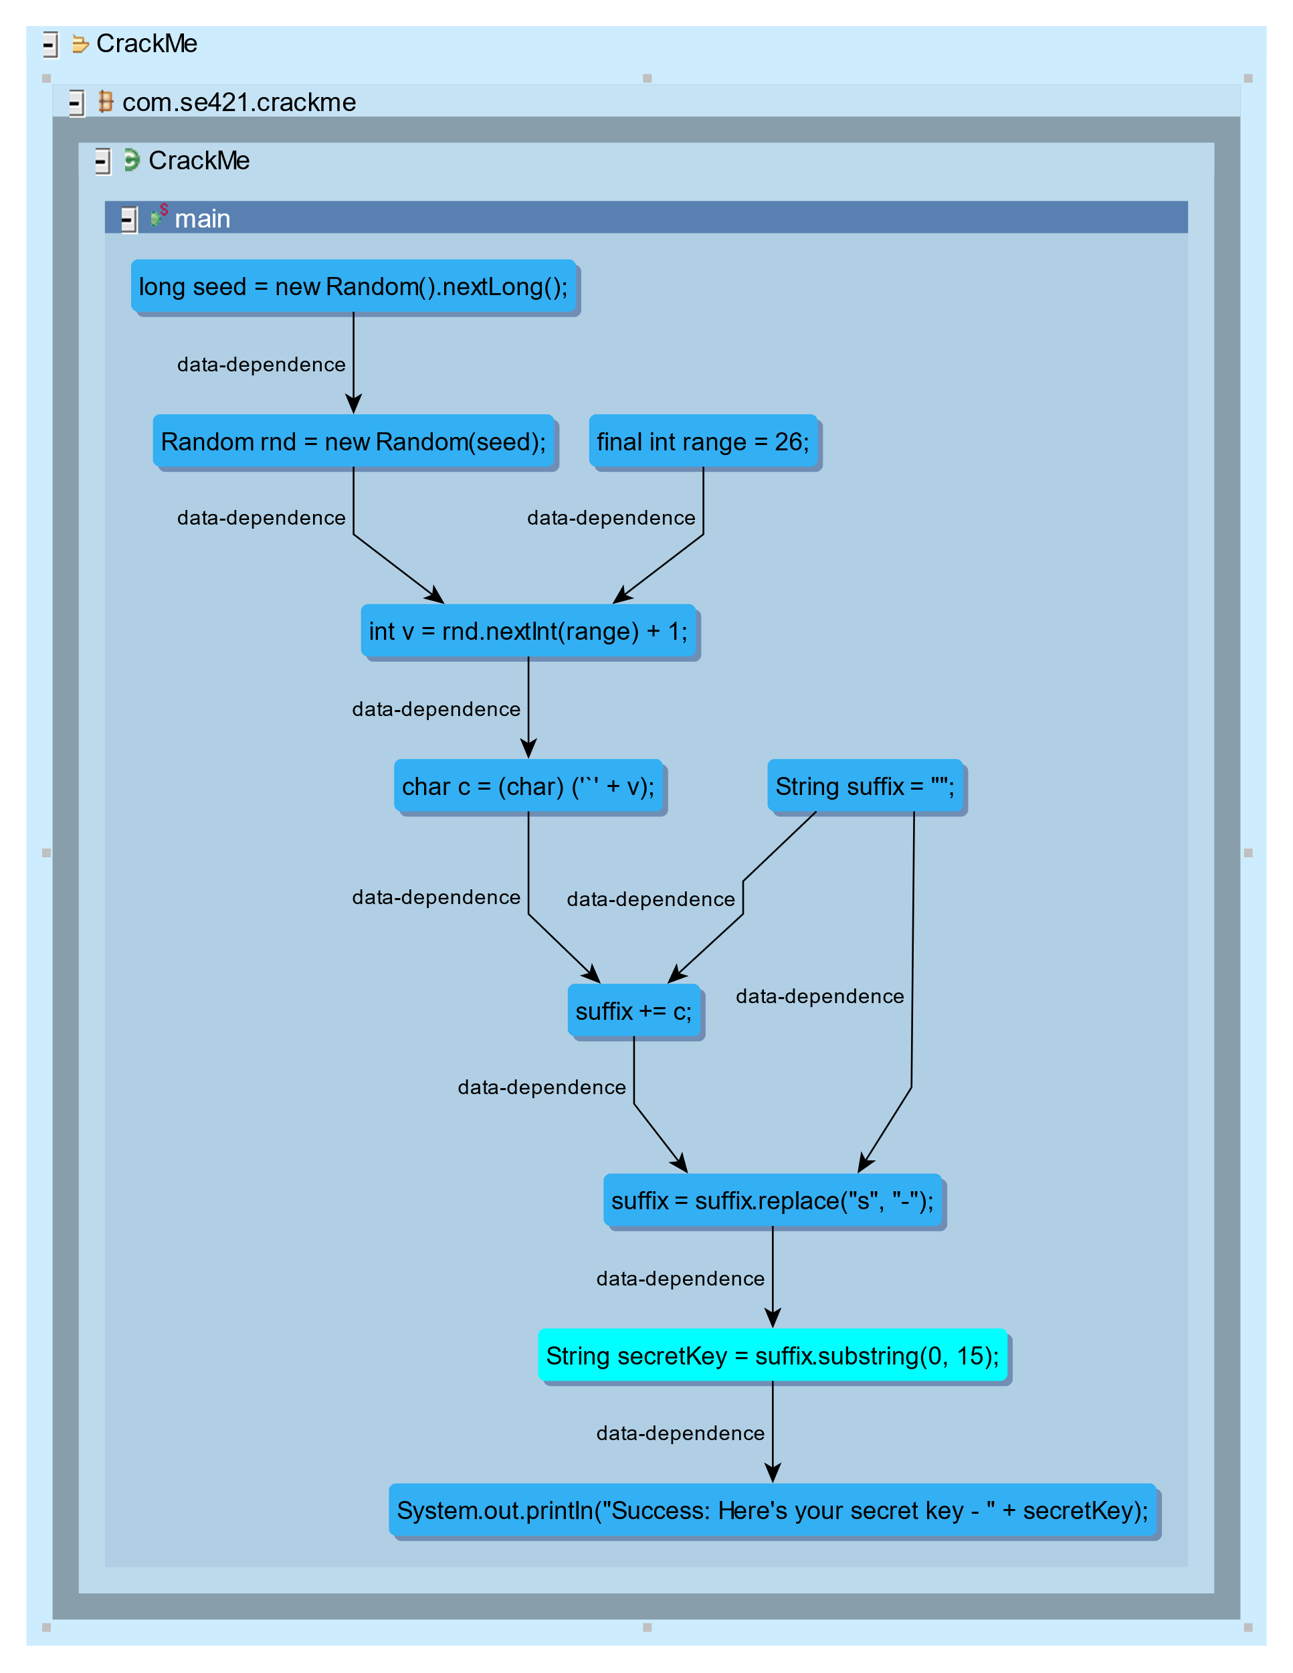
3. (**Bonus Points 2**) Using the slice, remove the irrelevant code from the CrackMe.java and produce the secret key. Give your program and the secret key.

